Volante Product Suite
SWIFT Message Pack SRG 2016

Contents
Release Notes 1
SRG 2016 1
Service Messages 1
System Messages 1
Changes To Release 2
Known Issues 2

Release Notes

This message pack consists of either system or service messages depending on the message pack selected.

Once the message pack is installed, the dictionary files (QualifierList.csv, SwiftField.xml, swift-field-dictionary-SRGXXXX.xml and SwiftSystemField.xml) will be available under Shared message library location (e.g.: D:\config\swift \dictionary\SRG XXXX) or local message library location (e.g.: Volante\config\swift\dictionary\SRG XXXX). This needs to be copied to $Designer_HOME\config\swift.

For more details about Shared message library location or local message library location please refer designer help.

SRG 2016

This release contains messages based on SWIFT’s System and Service messages specification (ufsm.pdf) released on 26th Feb 2016. The changes include newly added messages, field changes, NVR changes, scope and description changes present in SRG 2016 specification.

Service Messages
Newly Added Messages: No
Messages updated: No

System Messages
Newly Added Messages: No

Messages updated
System Messages | Changes
MT073 | Updated text of system message MT073
MT082 | Tag added for system message MT082
MT097 | Tag added, Updated text for system message MT097

Tags Added
- 111
- 121
- 165

Tags Removed: None

Changes To Release
Mar 01 2016:
First Release

Mar 08 2016:
Minor bug fix to make sure there is clean upgrade from SRG 2015 to SRG 2016 version.

Known Issues

- MT074 Broadcast Request (System Message)

In field tag 130 it says If (tag 130:/09/…) or (tag 130:/23/…) is present, then tag 132 or tag 133 but not both, must be used. But in tag 132 and 133 it says as below-
- Tag 132 can only be present if tag 130:/09/ or tag 130:/32/ is present.
- Tag 133 can only be present if tag 130:/09/ or tag 130:/32/ is present.

In field tag 130 there are no codes that start with /32/. This clearly seems to be a printing mistake since the same is given under tag 130. Hence we have assumed it to be /23/ and added validations.

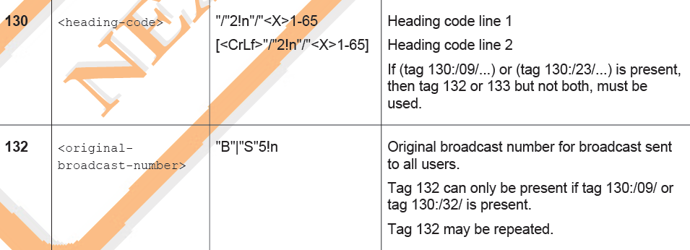
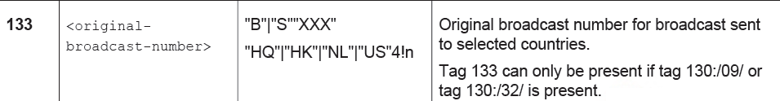

- MT096 FINCopy to Server Destination Message not included (System Message):

In System message spec (page:153), the message MT096 does not contain any Tags or formats for the field Copy-message and also mentions in the comments as “All or selected fields of the original message”. Since the format is not given in the spec this message is not included in this release.

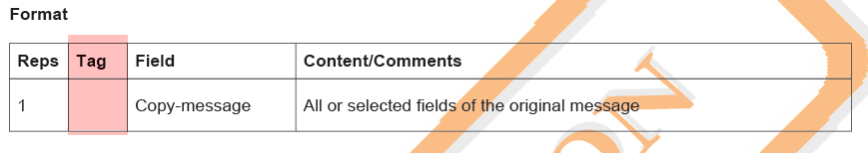

- MT021 Retrieved Message (Text and History) not included (System Message):

In System message spec (page:46), the message does not contain Tags or formats for fields header, text and trailers. Since the format is not given in the spec this message is not included in this release.
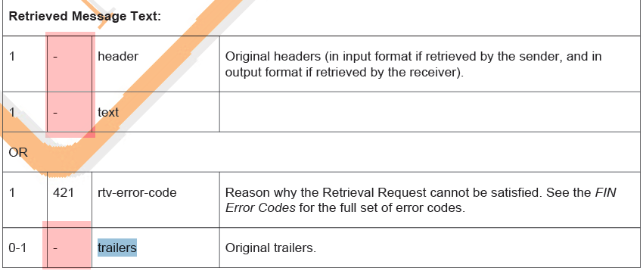

- T34 validation error will be thrown during serialization if tags (108, 113, 114, 115 & 424) contain only spaces.

As per spec for System messages, description for tag 108 and other tags has been updated as shown below.
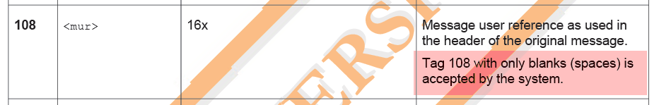
These tags are present in the below messages-

Tags | Messages
108 | MT010, MT011, MT012, MT019, MT020, MT022, MT023, MT066, MT082, MT083
113 | Not used in any System Message
114 | MT012, MT097
115 | MT097
424 | Not used in any System Message

For the above tags, if blank space is given T34 validation error will be thrown while serializing.

